SENTINEL FORENSICS: TOP 5 CHALLENGES
Technical Reference for Project Presentation
1. Model Overfitting (Generalization Error)
CHALLENGE:
The CNN model achieved high training accuracy but performed poorly on validation data, indicating it was memorizing noise rather than learning robust forensic features.
Explanation with an examples:
- Imagine a student who is preparing for an exam. They have completely memorized the answers to the past 5 years' question papers—this represents our Training Data.
If you ask them a question exactly from those past papers, they will score a perfect 100%—this represents High Training Accuracy.
However, on the actual exam day—which represents our Real-world Testing—when the examiner slightly tweaks the values in the questions, the student fails because they only memorized the answers and didn't understand the core concepts. This represents Low Validation Accuracy

SOLUTION WE FOUND TO SOLVE THE ISSUE:
1. Dropout Layers: We integrated Dropout layers with a 50% rate. Technically, this randomly deactivates half of the neurons during each training step. It prevents the model from becoming over-reliant on specific paths or 'star neurons.' This forces the entire network to learn robust, distributed features, ensuring the model doesn't just memorize the data but actually understands it.
2. Data Augmentation: We also utilized Data Augmentation to artificially expand our dataset. By applying random rotations, horizontal flips, and zooms to the images during training, we ensured the CNN never saw the exact same image twice. This forced the model to focus on invariant forensic features and AI artifacts rather than fixed pixel coordinates, significantly improving its performance on real-world, unseen data."
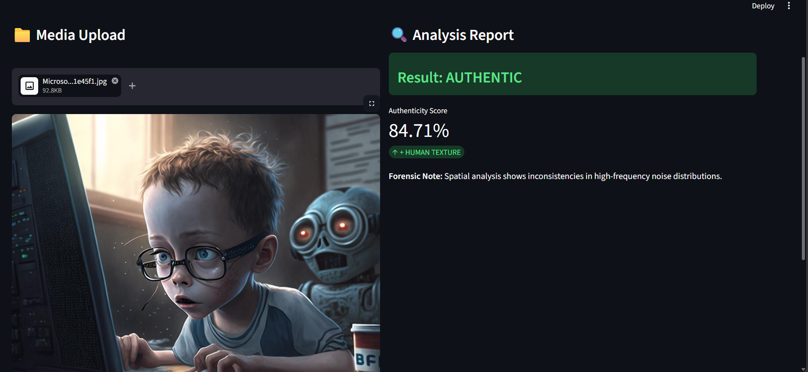

2. Domain Shift & False Positives (Webcam Data)
2. Domain Shift & False Positives (Webcam Data)
CHALLENGE:
Our model was trained on the CIFAKE dataset, which consists of low-resolution, 32x32 synthetic images. However, when we moved to real-world testing using high-definition webcams, the model struggled. The HD captures contained natural skin textures, environmental lighting, and digital sensor noise that were absent in the training data. The CNN misinterpreted this 'real-world noise' as 'synthetic artifacts,' incorrectly labeling authentic photos as AI-generated.

SOLUTION:
Our process was straightforward:
- Dataset Collection: We started by collecting and structuring the CIFAKE dataset to train our core CNN model.
- To fix this, we integrated OpenCV into our pipeline. Instead of giving the full raw image to the model, OpenCV isolates the user's face and standardizes it.



CHALLENGE:
The CIFAKE dataset (32x32) differed significantly from high-res HD webcam captures. Natural skin pores and lighting were misinterpreted as "AI noise" artifacts.
SOLUTION:
Built a Face Isolation Pipeline using OpenCV. By stripping background noise and applying 0-1 Pixel Normalization, the model's focus was restricted to facial artifacts 2. Domain Shift & False Positives (Webcam Data)
CHALLENGE:
The CIFAKE dataset (32x32) differed significantly from high-res HD webcam captures. Natural skin pores and lighting were misinterpreted as "AI noise" artifacts.
SOLUTION:
Built a Face Isolation Pipeline using OpenCV. By stripping background noise and applying 0-1 Pixel Normalization, the model's focus was restricted to facial artifacts

High-resolution 4K images (50MB+) create massive computational overhead, leading to "Out of Memory" (OOM) errors on cloud servers. Additionally, unauthenticated file formats (PDFs/Docs) can crash the inference engine. High-resolution 4K images (50MB+) create massive computational overhead, leading to "Out of Memory" (OOM) errors on cloud servers. Additionally, unauthenticated file formats (PDFs/Docs) can crash the inference engine.
3. High-Resolution Scaling & Data Authentication
CHALLENGE:
High-resolution 4K images (50MB+) create massive computational overhead, leading to "Out of Memory" (OOM) errors on cloud servers. Additionally, unauthenticated file formats (PDFs/Docs) can crash the inference engine.
SOLUTION:
Authentication Layer: Implemented a strict file-type validation filter to ensure only authorized image formats are processed.
- Intelligent Scaling: Used OpenCV’s Recursive Downsampling with INTER_AREA interpolation. This scales 4K images down to the 32x32 input layer while preserving the high-frequency forensic artifacts required for accurate AI detection.

